**Minor Project Report**

***Acquittal Search***

Submitted in partial fulfilment of the requirements

for the award of the degree of

**Bachelor of Technology**

**In**

**Computer Science and Engineering**

**Guide:** **Submitted by:** **Roll No.:**

Urvashi Sugandh Jasti Sri Radhe Shyam 02413302714

Assistant Professor, HMRITM Vidit Agarwal 02313302714 Gaurav Badola 01113302714 Vysakh Raju 01113302714

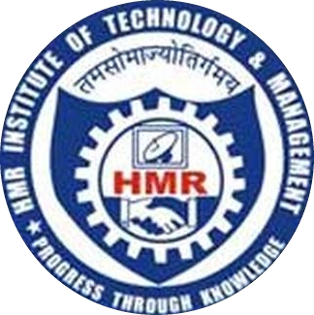

**HMR INSTITUTE OF TECHNOLOGY&MANAGEMENT**

**HAMIDPUR, DELHI 110 036**

**Affiliated to**

**GURU GOBIND SINGH INDRAPRASTHA UNIVERSITY**

**Sector - 16C Dwarka, Delhi - 110075, India**

**2014 – 2018**